# Our Prototype

Our Prototype

Flow

Screens

Overlay

## Flow

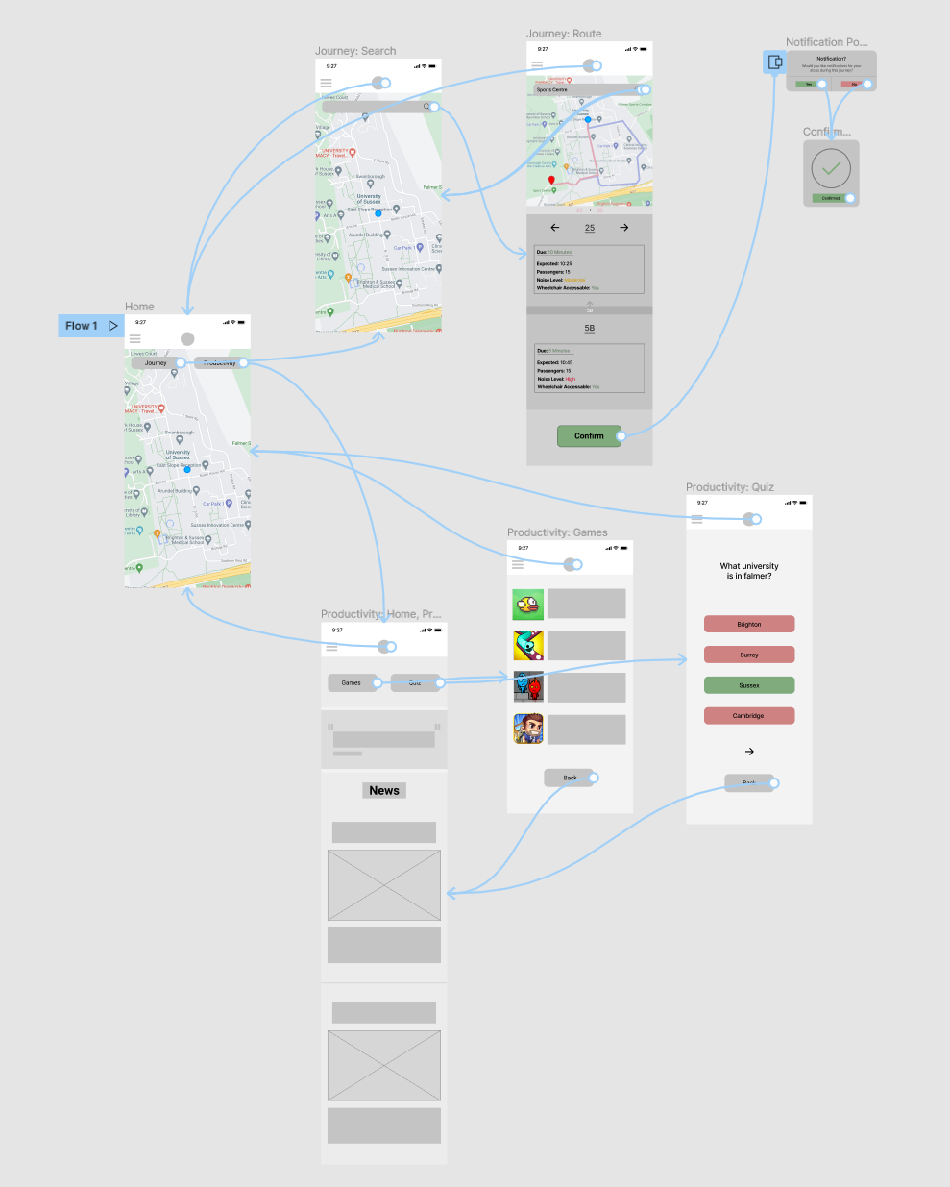

This shows the general UX flow created from the separate screens and overlays when interacted with.

## Screens

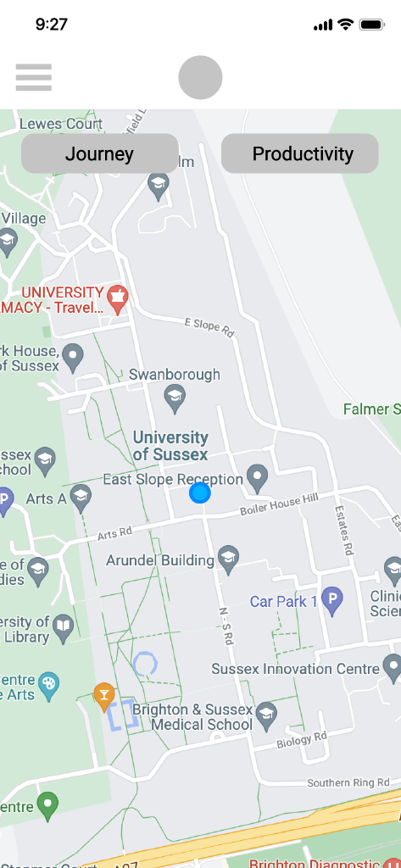

This is the home screen, the blue dot in the center is your current location.

The journey button allows you to create a journey.

Productivity takes you to the productivity section.

The circle up top is the home button.

The menu on the side is an overview, however in the prototype we did not add functionality for it.

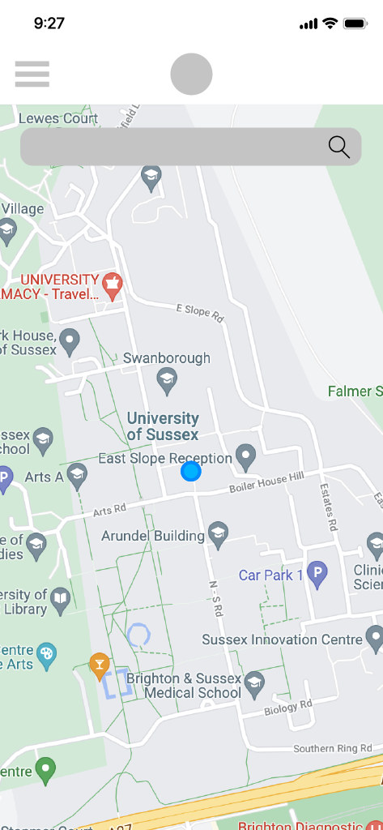

When tapping the journey, the search bar comes up for a user to search for a location to go to.

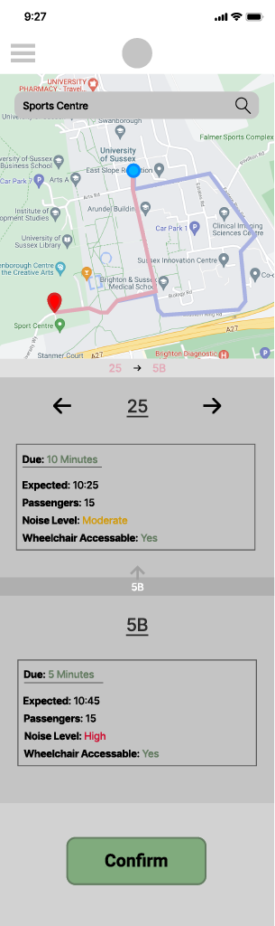

When a journey is set (Home → journey button → search bar → type location), it shows the route and the chain of busses to take, with the information for each bus. A confirm button is available to confirm the route. When clicking the confirm button, the notification overlay (see bottom of document) shows up to ask if they want notifications for the stops ahead.

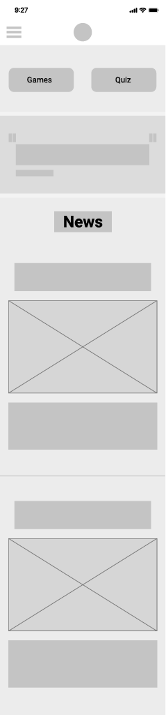

When clicking on the production button on home, this is the section it takes you to. It displays two buttons, one for games and the other to take a quiz. The next section down, has a small inspirational quote to make you feel more inspired to be productive. After, is the local news section which displays the newest local news articles.

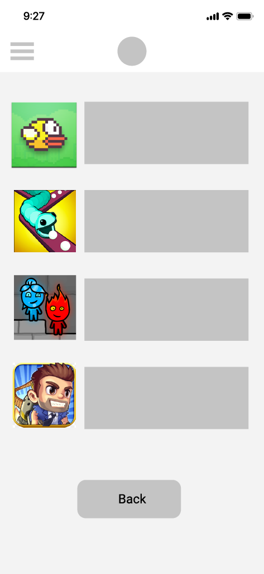

When a user goes into “Games” from the productivity section, this following is shown which allows you to select a game from a list. None of the games are playable for obvious reasons. The back button goes back to the productivity section.

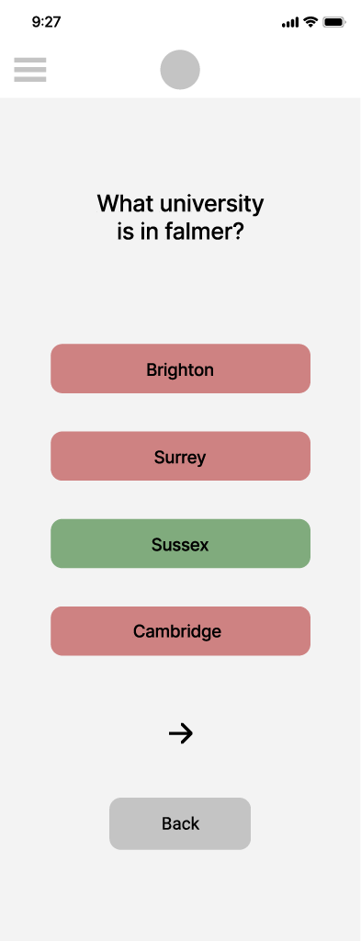

When accessing the quiz section after going into productivity, it displays a random question, it allows you to answer and move forward or go back.

## Overlay

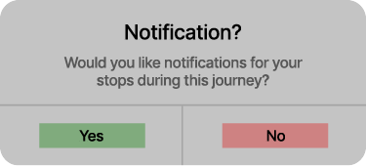

After selecting a route and confirming, this pop-up displays if you want notifications for your stops during your journey.



Once notifications are accepted or denied for the journey, another popup confirms that it has worked.